XRD report for NiO nanoparticles _

In the This one stage were _ measured through X - ray diffraction (XRD) a number of four samples below powder form _ with granulation fine , without the need for preparation specific . The measurements were conducted use diffractometer Bruker *D8 Advance* in the Bragg-Brentano geometry , with *Cu* anode _ and filter *Ni* ( radiation *k  , λ* = 0.154184 nm) in a range angular wide , up to 2  = 140 o , for a better precision in the dETERMINATION network parameters . _

In the figure 1 are represented difractograms the four tests. Samples NiO-1_400, NiO-1_500 and NiO-2_400 show diffraction patterns similar , phase indexed _ unique cubic NiO , group spatial Fm-3m (225), according to ICDD - 01-071-1179. Rietveld analysis of diffractograms (software *Topas* v.3 - Bruker) determined same network parameter _ *a* = 0.4178 ± 0.0001 nm for all samples and size crystallite media _ *d* = 11 ± 2 nm for sample NiO-1_400 and *d* = 18 ± 2 nm for NiO-1_500 and NiO -2_400 samples. Figure 2 shows that example the outcome the fitting diffractogram sample NiO-1_400 with NiO structure cubic with parameters *of* and *d* mentioned above, demonstrating present of a phases unique with grains polycrystalline .



**Figure 1.** X -ray diffractograms of the indicated samples . Probes NiO-1_400, NiO-1_500

and NiO-2_400 are indexed ( tags black ) with phase unique NiO _ cubic . For sample

NiO-rGO_400 was indexed ( tags green ) phase additional C-2H ( 2H graphite ).

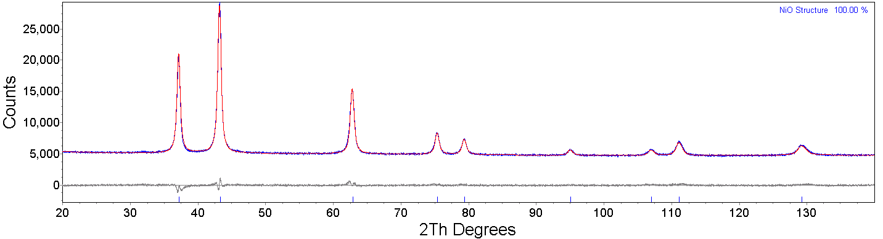

**Figure 2.** X - ray diffractogram of sample NiO-1_400 ( blue ) and simulation

with NiO structure cubic ( red ) with parameters *of* and *d* mention in the text .

It is represented by a gray line the difference the two curves .

Diffractogram sample NiO-rGO_400 (Figure 1, line green ) presents so much peaks phases NiO cubic How and peaks more indexed ( tags green ) with phase hexagonal C-2H ( graphite 2H), group spatial P63 / mmc (194), according to ICDD - 00-056-0159, showing that This one sample is a composite of _ two phases crystalline . Analyze Rietveld determined _ for graphite phase _ network parameters _ *a* = 0.2460 ± 0.0001 nm and *c* = 0.6707 ± 0.0001 nm and maximum crystallite size *d* = 35 ± 4 nm on direction perpendicular on plane (002), at 2 θ= 26.5 o , which shows orientation preferential - texture . This one may be suggests a morphology preponderance platelet . For phase NiO was determined network parameter _ *a* = 0.4177 ± 0.0001 nm and size crystallite media _ *d* = 7 ± 2 nm. Figure 3 shows the outcome the fitting diffractogram sample with two structures : NiO cubic and graphite with parameters *of* and *d* mentioned above.

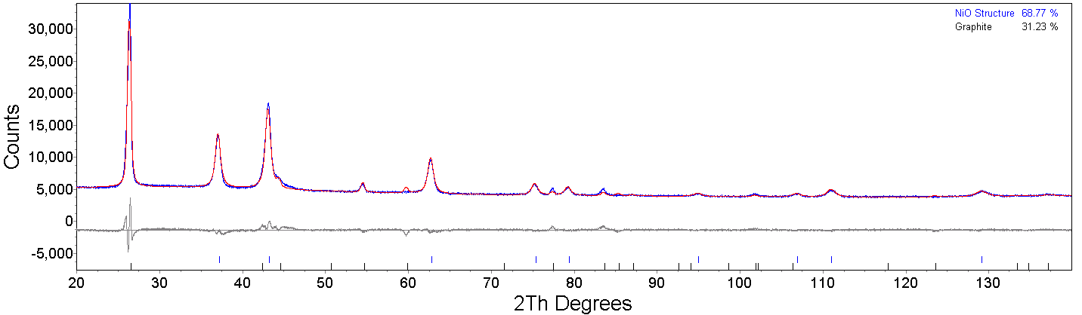

**Figure 3.** X - ray diffractogram of sample NiO-rGO_400 ( blue ) and simulation ( red )

with two structures : NiO cubic and graphite with parameters *of* and *d* mentioned in the text .

It is represented by a gray line the difference the two cur be .